Sample template
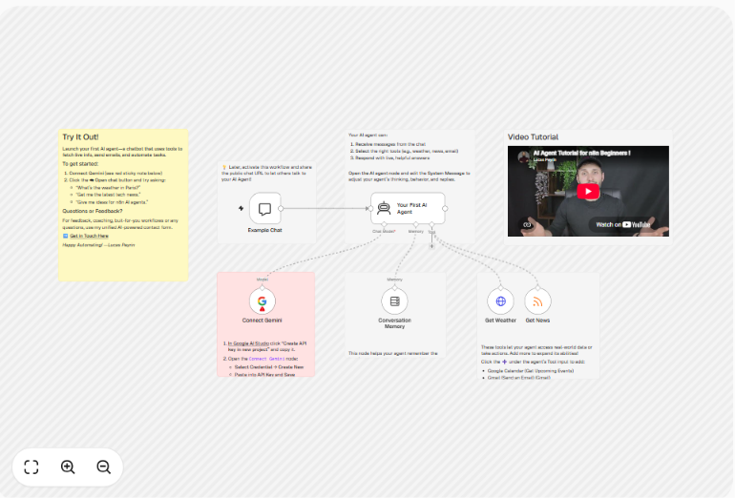

Established workflow :

- Wikipedia

Workflow
Trigger - Chat message
AI Agent
Groq chat model
Memory
Wikipedia

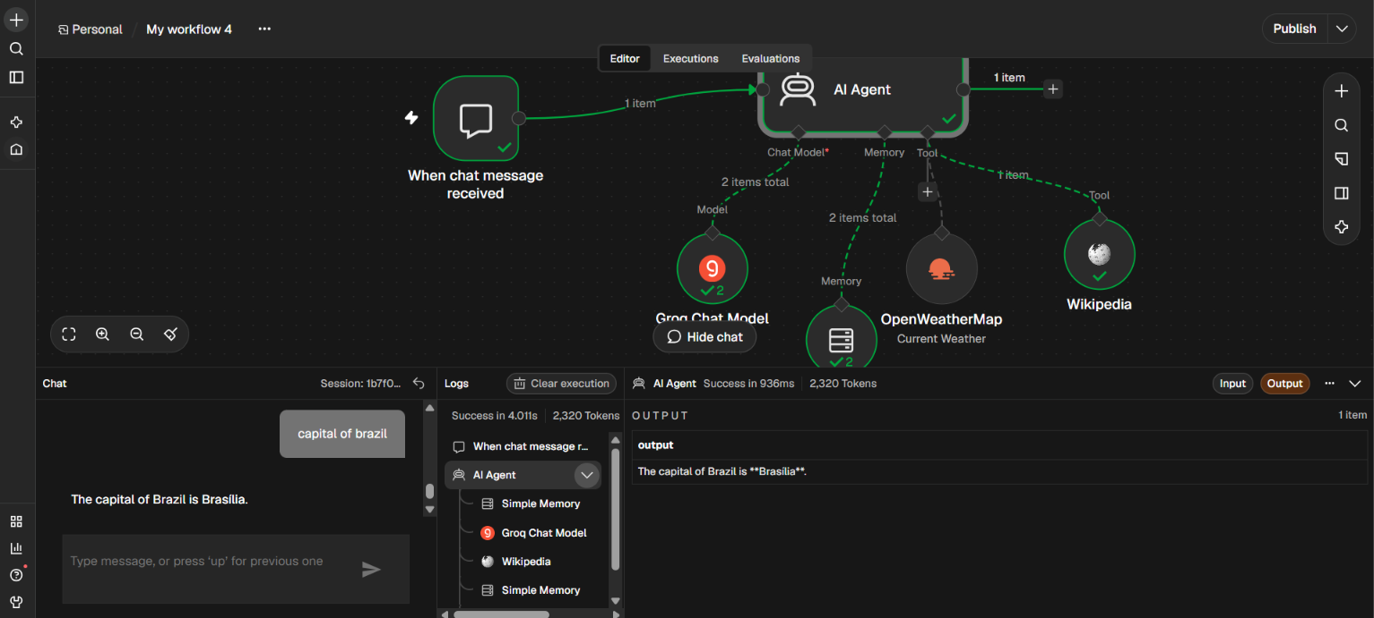

2 - Weather details
Workflow
Trigger - Chat message
AI Agent
Groq chat model
Memory
Openweather - API key


